# Steps to review before Running the Hamilton

### Before Running ***ANY*** Method, please check if the Daily and Weekly Maintenance was done on the machine

## Setting up and Running the Maintenance Program

* Open the Hamilton Run Control application
  + Go to the Settings tab and make sure Simulation Mode is turned off
  + Live Mode = Green Light
  + Simulation Mode = Yellow Light
* 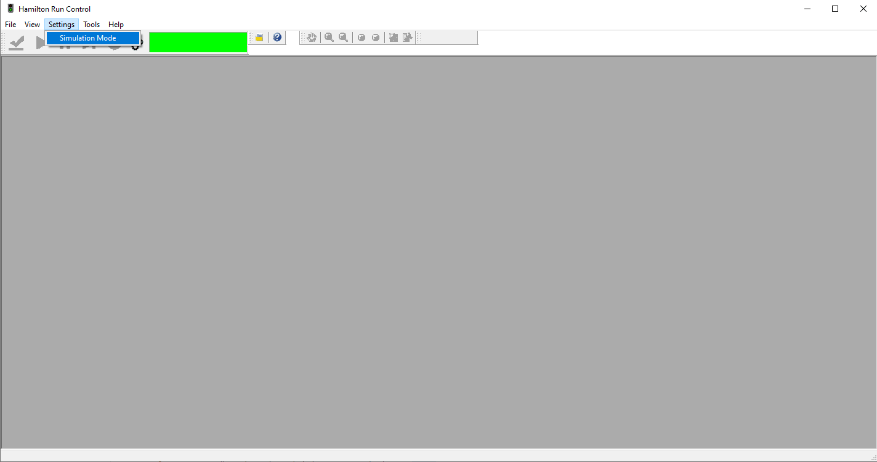
* Run Control
* Open the Daily Maintenance application
  + Select Daily and Weekly Maintenance options. They will have a red **Required** text next to them if they need to be ran.
  + Follow the instructions and prompts shown during the maitenance program
  + Once the process is finihed, initial/date and fill out the corresponding sections in the Hamilton EQ1846 Logbook
  + If any errors occurs, please follow the instructions as stated in SOP-EQ-78
* 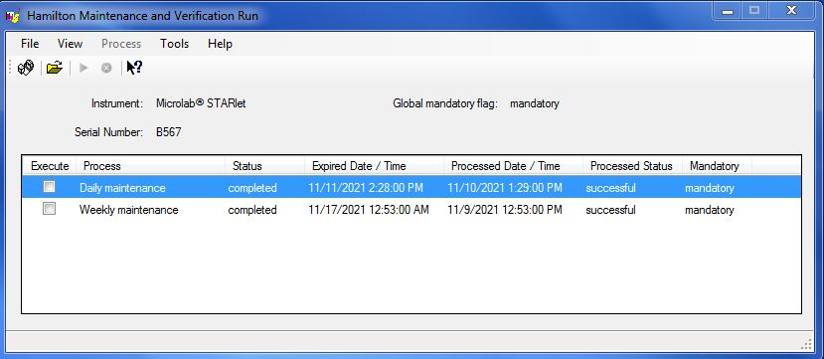
* Maintenance

## Steps To Run a Hamilton Method

1. Open the Hamilton Run Control application and enable **Simulation Mode**
2. Use the Hamilton Method Manager application to select your method and hit run
3. Upon a *successful* simulation run, go back to the Hamilton Run Control application and disable **Simulation Mode**
4. Use the Hamilton Method Manager application to run your method again in live mode 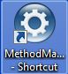



1. A menu should pop up as seen below 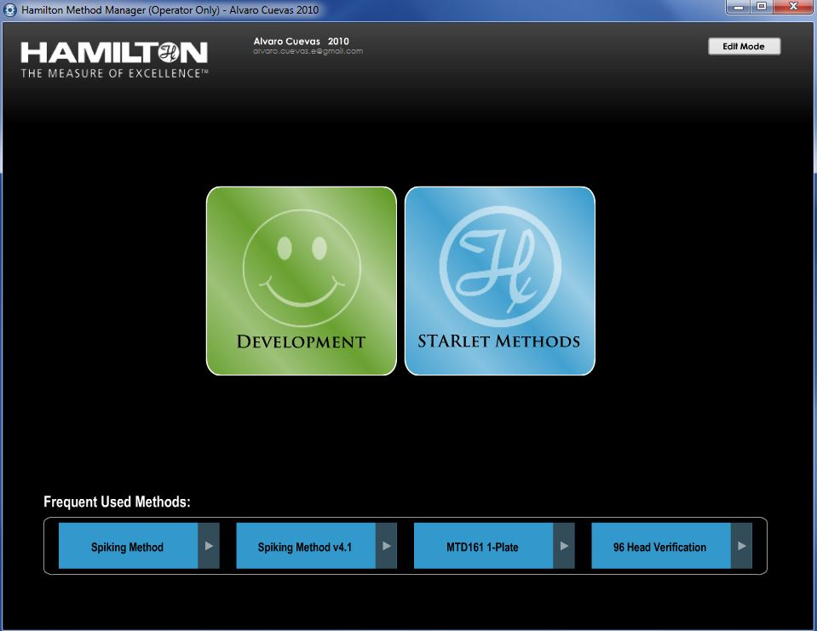
2. The STARlet Methods icon will bring up a menu listing all available methods. Hit **Run** to launch the a method. 